**INDUSTRY INTERNSHIP SUMMARY REPORT**

Java FSD (Full Stack Development) with React Intern and Full Time

**BACHELOR OF TECHNOLOGY**

**in**

**COMPUTER SCIENCE AND ENGINEERING**

***Submitted by***

# Harshit Mishra (19SCSE1010099)



# SCHOOL OF COMPUTING SCIENCE AND ENGINEERING

**GREATER NOIDA, UTTAR PRADESH**

**Winter 2021 – 2022**

**BONAFIDE CERTIFICATE/ OFFER LETTER**

## CERTIFICATE

I hereby certify that the work which is being presented in the Internship project report entitled “Full stack developer Intern and Full Time“ in partial fulfillment for the requirements for the award of the degree of Bachelor of Technology in the School of Computing Science and Engineering of Galgotias University , Greater Noida, is an authentic record of my own work carried out in the industry.

To the best of my knowledge, the matter embodied in the project report has not been submitted to any other University/Institute for the award of any Degree.

**Harshit Mishra (19SCSE1010099)**

This is to certify that the above statement made by the candidate is correct and true to the best of my knowledge.

Signature of Internship Coordinator **Signature of Dean (SCSE)**

Dr.N.Partheeban **Dr. MUNISH SABHARWAL**

Professor & IIIC Professor & Dean

School of Computing Science & Engineering School of Computing Science & Engineering

Galgotias University Galgotias University Greater Noida. Greater Noida.

## TABLE OF CONTENTS

**CHAPTER TITLE PAGE NO**

Abstract **5**

List of Figures & List of Tables **6-7**

List of Abbreviations **8**

1. **Introduction 9** 
   1. Objective of the project
   2. Problem statement and research objectives
   3. Description of Domain

* 1. A brief introduction about an organization.

1. **Technical Description 10-15**
2. **System Design** 
   1. General Architecture
   2. Design Phase 
      1. Data flow diagram
      2. UML Diagrams
   3. Methodology
3. **System Implementation 16-25**
4. **Results and Discussions 26**
5. **Conclusion and Future Work 27-28**
6. **Appendices-** 
   1. Source Code

**29-30**

* 1. Learning Experiences
  2. SWOT Analysis

## ABSTRACT

This abstract outlines the benefits and goals of pursuing an internship in Java Full Stack Development with React as an intern at TEKSystems Global Services. The internship offers an opportunity to gain practical experience in developing web applications using the Java programming language and the React framework. The internship focuses on full-stack development, which involves working with both front-end and back-end technologies.

During the internship, participants will learn how to design and develop web applications, build and integrate APIs, work with databases, and implement security features. Participants will also develop their skills in HTML, CSS, JavaScript, and various web development tools.

The goals of the internship include enhancing participants' knowledge and skills in web development, exposing them to real-world scenarios, and preparing them for a career in the field. The internship also offers opportunities for networking, learning from experienced professionals, and gaining exposure to the latest technologies.

Upon completing the internship, participants will have a solid understanding of Java Full Stack Development with React and be better equipped to pursue a career in web development. They will have hands-on experience working on projects and will have developed the skills and confidence to tackle complex problems in the field.

Overall, pursuing an internship in Java Full Stack Development with React can be a rewarding experience for individuals who are passionate about web development and interested in gaining practical skills in Java and React. The internship can offer a valuable stepping stone towards a career in software engineering and provide opportunities for personal and professional growth.

## LIST OF FIGURES

**S. NO FIG. NO TITLE PAGE. NO**

1. **3.1** Main Screen 16
2. **3.2**  List the files 16
3. **3.3** Perform operations on file 17
4. **3.4** Performing add operation 17
5. **3.5** Main page assignment 18
6. **3.6** Login page 18
7. **3.7** Error message on wrong credential 19
8. **3.8** Fully functional Admin home page 19
9. **3.9** Page for payment successful 19
10. **3.10** Main page assignment3 20
11. **3.11** Admin Login 20
12. **3.12** Home page 20
13. **3.13** Add to cart page 21
14. **3.14** Product list page 21
15. **3.15** Dummy payments page 21
16. **3.16** Landing page 22
17. **3.17** Selecting right answer 22
18. **3.18** Selecting Wrong answer 23
19. **3.19** Result Page 23
20. **3.20** Landing Page 24
21. **3.21** On searching pokemon data from database 24
22. **3.22** Pokemon dropdown shown from database 25
23. **3.23** On clicking to read more, redirects to 25

pokeymon info page

**LIST OF ABBREVIATIONS**

HTML Hypertext Markup Language

CSS Cascading Style Sheet

JS Java Script

**CHAPTER 1**

## INTRODUCTION

Java Full Stack Development with React (Spring Boot, Hibernate) is a popular and powerful web development framework that enables developers to create dynamic and responsive web applications. It combines the Java programming language, which is widely used for server-side development, with React, a front-end JavaScript library that enables developers to build interactive and user-friendly web interfaces.

Spring Boot, an open-source framework, is an essential component of Java Full Stack Development with React. It provides a robust platform for building and deploying web applications quickly and easily, with minimal configuration required. Spring Boot offers many features, including embedded Tomcat and Jetty web servers, easy integration with various databases, and automatic configuration for Spring-based applications.

Hibernate, another critical component of Java Full Stack Development with React, is an objectrelational mapping (ORM) tool that simplifies database interactions in Java applications. It enables developers to map Java objects to database tables and execute SQL queries automatically, reducing the amount of boilerplate code required to manage database operations.

The combination of Spring Boot and Hibernate in Java Full Stack Development with React provides developers with a robust and efficient platform for building web applications. Developers can take advantage of the Spring framework's many features, including dependency injection, aspectoriented programming, and easy integration with other frameworks and libraries. At the same time, Hibernate simplifies database interactions, making it easier for developers to create, read, update, and delete records in their applications.

React, on the other hand, is a popular front-end JavaScript library that provides a simple and intuitive way to build interactive user interfaces. React enables developers to create reusable UI components that can be easily combined to create complex web applications. With React, developers can build applications that are fast, responsive, and scalable.

In summary, Java Full Stack Development with React (Spring Boot, Hibernate) is a powerful and popular web development framework that enables developers to create dynamic and responsive web applications. With the combination of Java, React, Spring Boot, and Hibernate, developers can create web applications that are efficient, scalable, and easy to maintain. The framework provides a robust platform for building web applications that can meet the needs of modern businesses and organizations.

## CHAPTER 2 TECHNICAL DESCRIPTION

**Below is technical description of the assignment1.**

### Link of the GitHub Repository[-](https://github.com/Janhavi2001/SimpliLearn_Project1.git)https://github.com/harshit116/ProjectCoreJava.git

**Overview:**

**Project objective:**

As a Full Stack Developer, complete the features of the application by planning the development in terms of sprints and then push the source code to the GitHub repository. As this is a prototyped application, the user interaction will be via a command line.

**Background of the problem statement:**

Company Lockers Pvt. Ltd. hired you as a Full Stack Developer. They aim to digitize their products and chose LockedMe.com as their first project to start with. You’re asked to develop a prototype of the application. The prototype of the application will be then presented to the relevant stakeholders for the budget approval. Your manager has set up a meeting where you’re asked to present the following in the next 15 working days (3 weeks):

Specification document - Product’s capabilities, appearance, and user interactions, Number and duration of sprints required, Setting up Git and GitHub account to store and track your enhancements of the prototype, Java concepts being used in the project, Data Structures where sorting and searching techniques are used. Generic features and three operations: 1) Retrieving the file names in an ascending order 2) Business-level operations:

1. Option to add a user specified file to the application
2. Option to delete a user specified file from the application
3. Option to search a user specified file from the application
4. Navigation option to close the current execution context and return to the main context 7) Option to close the application

The goal of the company is to deliver a high-end quality product as early as possible. The flow and features of the application:

1. Plan more than two sprints to complete the application
2. Document the flow of the application and prepare a flow chart
3. List the core concepts and algorithms being used to complete this application 4) Code to display the welcome screen. It should display:

1. Application name and the developer details
2. The details of the user interface such as options displaying the user interaction information
3. Features to accept the user input to select one of the options listed
4. The first option should return the current file names in ascending order. The root directory can be either empty or contain few files or folders in it

The second option should return the details of the user interface such as options displaying the following:

1. Add a file to the existing directory list
2. You can ignore the case sensitivity of the file names
3. Delete a user specified file from the existing directory list
4. You can add the case sensitivity on the file name in order to ensure that the right file is deleted from the directory list
5. Return a message if FNF (File not found)
6. Search a user specified file from the main directory
7. You can add the case sensitivity on the file name to retrieve the correct file
8. Display the result upon successful operation
9. Display the result upon unsuccessful operation
10. Option to navigate back to the main context
11. There should be a third option to close the application
12. Implement the appropriate concepts such as exceptions, collections, and sorting techniques for source code optimization and increased performance

**Below is technical description of the assignment 2.**

### Link of the GitHub Repository[-](https://github.com/Janhavi2001/SimpliLearn_Project2.git)https://github.com/harshit116/projectbackend.git

**Project objective:**

As a Full Stack Developer, design and develop an airline booking portal named as FlyAway. Use the GitHub repository to manage the project artifacts.

**Background of the problem statement:**

Fly-Away is a ticket-booking portal that lets people book flights on their website. The website needs to have the following features:

1. A search form in the homepage to allow entry of travel details, like the date of travel, source, destination, and the number of persons.
2. Based on the travel details entered, it will show the available flights with their ticket prices.
3. Once a person selects a flight to book, they will be taken to a register page where they must fill in their personal details. In the next page, they are shown the flight details of the flight that they are booking, and the payment is done via a dummy payment gateway. On completion of the payment, they are shown a confirmation page with the details of the booking.

For the above features to work, there will be an admin backend with the following features:

* 1. An admin login page where the admin can change the password after login, if he wishes
  2. A master list of places for source and destination
  3. A master list of airlines
  4. A list of flights where each flight has a source, destination, airline, and ticket price

The goal of the company is to deliver a high-end quality product as early as possible. The flow and features of the application:

* 1. Plan more than two sprints to complete the application
  2. Document the flow of the application and prepare a flow chart
  3. List the core concepts and algorithms being used to complete this application
  4. Implement the appropriate concepts, such as exceptions, collections, and sorting techniques for source code optimization and increased performance

You must use the following:

* 1. Eclipse/IntelliJ: An IDE to code for the application
  2. Java: A programming language to develop the web pages, databases, and others
  3. SQL: To create tables for admin, airlines, and other specifics
  4. Maven: To create a web-enabled Maven project
  5. Git: To connect and push files from the local system to GitHub
  6. GitHub: To store the application code and track its versions
  7. Scrum: An efficient agile framework to deliver the product incrementally
  8. Search and Sort techniques: Data structures used for the project
  9. Specification document: Any open-source document or Google Docs

**Below is technical description of the assignment 3.**

### Link of the GitHub Repository[-](https://github.com/Janhavi2001/SimpliLearn_Project3.git) https://github.com/harshit116/projectbackend.git

**Project objective:**

As a Full Stack Developer, complete the features of the application by planning the development and pushing the source code to the GitHub repository.

**Background of the problem statement:**

Sporty Shoes is a company that manufactures and sells sports shoes. They have a walk-in store, and now, they wish to launch their e-commerce portal sportyshoes.com.

The task is to develop a prototype of the application. It will be then presented to the relevant stakeholders for budget approval. Your manager has set up a meeting where you’re asked to do the following:

1. Presenting the specification document which has the product’s capabilities, appearance, and user interactions
2. Setting up Git and GitHub account to store and track your enhancements of the prototype
3. Explaining the Java concepts used in the project 4) Discussing the generic features of the product:

5) There will be an admin to manage the website. An administrator login will be required to access the admin page.

The admin should be able to change his password if he wants, he should be able to:

1. Manage the products in the store including categorizing them
2. Browse the list of users who have signed up and be able to search users 3) See purchase reports filtered by date and category

**Below is technical description of the assignment 4.**

### Link of the GitHub Repository[–](https://github.com/Janhavi2001/QuizApp.git) https://github.com/harshit116/Quiz.git

**Project objective:**

The Online Test Application system creates an application that enables users to provide online tests, review them, and display the results.

**System Details:**

This system contains three main modules: Quiz, Review, and Result. The quiz section of the online test application accepts the questions in JSON format. The JSON file can be easily shared from the server in the pre-defined format. The application renders the test at the client-side.

The “Review and display result” section allows users to declare the results immediately. You can simply call another JSON with the answers in it and evaluate and display the results immediately.

**Product Capabilities:**

The Online Test Application system creates an application that enables users to provide online tests, review them, and display the results. As soon as the application is run using “index.html” file the user should see the screen where the question is displayed and the user has to select one of the four questions and as soon as the user selects the correct answer is marked with green colour and this is the review part of the application. And if selected wrong the option is marked with red, Moreover, the user will not be able to mark another option after choosing one. User can switch the questions using “Next” button. Once the quiz is over the application automatically generates the result. The program is error-free and handles all conceivable situations.

The USPs (UNIQUE SELLING POINTS) are that: a) Handles corner cases:

1. Doesn’t show any error at any circumstances and
2. Satisfies all the specifications required.
3. Build on JavaScript
4. Have a nice display screen and user-friendly

As a result, the application complies with the user requirements papers and is very user-friendly.

**Below is technical description of the assignment 5.**

### Link of the GitHub Repository[-](https://github.com/Janhavi2001/SimpliLearn_Project5.git) https://github.com/harshit116/pokemon.git

**Project objective:**

In the world of pokemon, where the user should be able to search for different pokemons, you have to create an application to search them with the following functionalities:

1. The Pokemon application should have the list of pokemon details which will be provided in the form of JSON data i.e., it should have name, image, CP, attack, defense type etc.
2. It should have a search bar so that user can search the pokemon based on the name of pokemon. Since we have many pokemon, apply pagination, so that user can only see 10 pokemon at a time.

**Description:**

Pagination should have “page current-page of Total pages”. For example: page 50 of 100 The total pages should be calculated based on the JSON data provided.

And the current page is calculated based on the page, the user is in, currently.

Pagination should have id=”pagination ”, which should contain the details as listed above.

The previous button should be disabled if it is in the first page and it should have id=”previous”. Next button, should show next set of pokemon (which is 10 pokemon on a click) and should have id=”next”. Search bar should have an id=”search ”. Pokemon's name should be inside the span tag (or any other tag) which should have id=”name”.

**Product Capabilities:**

The Pokemon application have the list of pokemon details which will be provided in the form of JSON data i.e., it has name, image, CP, attack, defense type etc. As soon as the application is run using “index.html” file the user should see the list of different pokemons and able to search the individual pokemon.

The application successfully handles the corner cases, for example, case sensitivity. There is also the card based user interface in the application so user may able to see the image , name and other details of the pokemon in the single card which makes the interface more clear and well defined.

**CHAPTER 3**

## SYSTEM IMPLEMENTATION

### Assignment 1 Implementation: https://github.com/harshit116/ProjectCoreJava.git

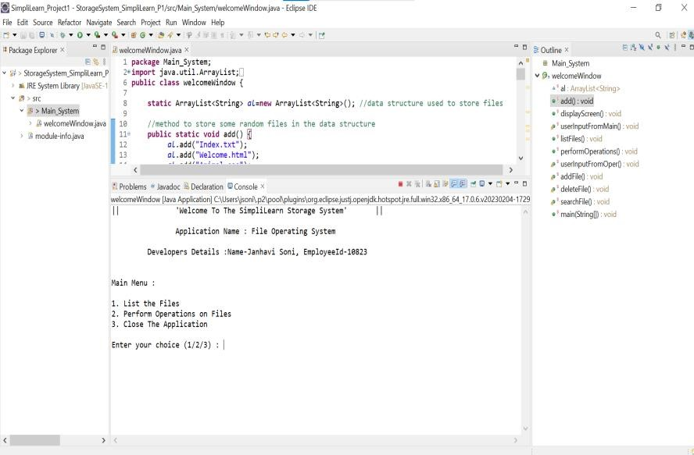

Fig: 3.1 Main screen

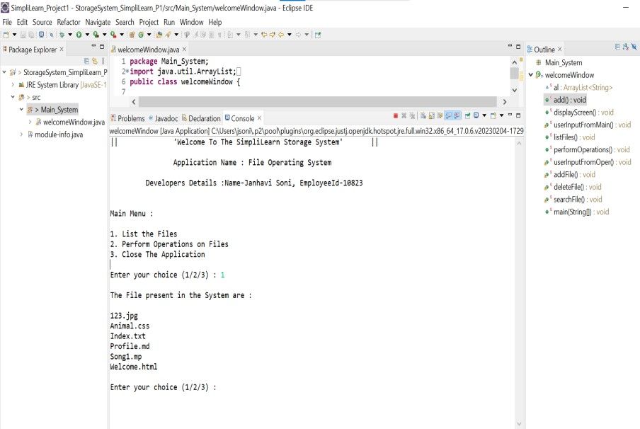

Fig 3.2: List the files (Taking input from user)

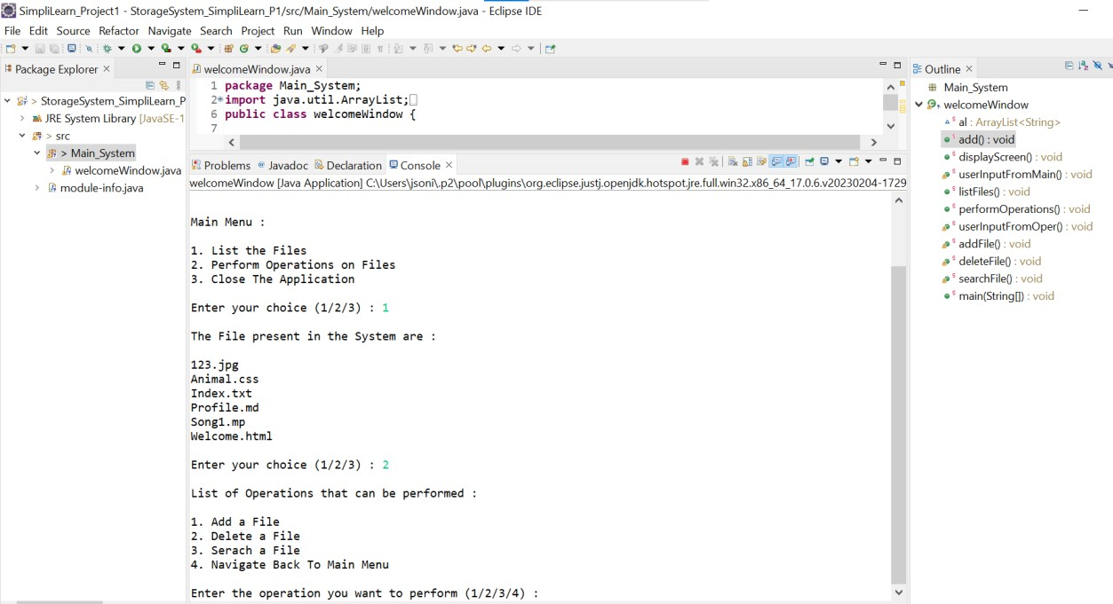

Fig 3.3: perform operations on file (taking input from user)

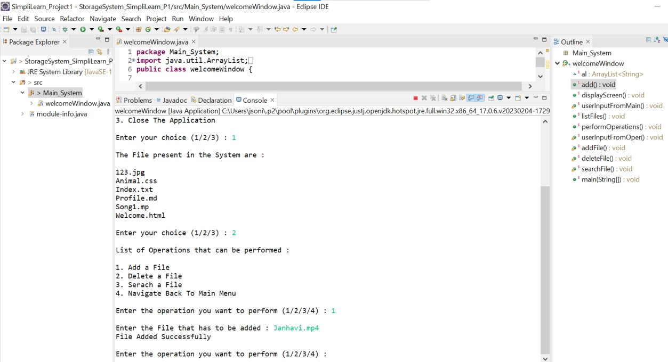

Fig 3.4 Performing add operation (taking input from user)

### Assignment 2 Implementation: [-](https://github.com/Janhavi2001/SimpliLearn_Project2.git)<https://github.com/harshit116/SimpliLearn_Project2.git>

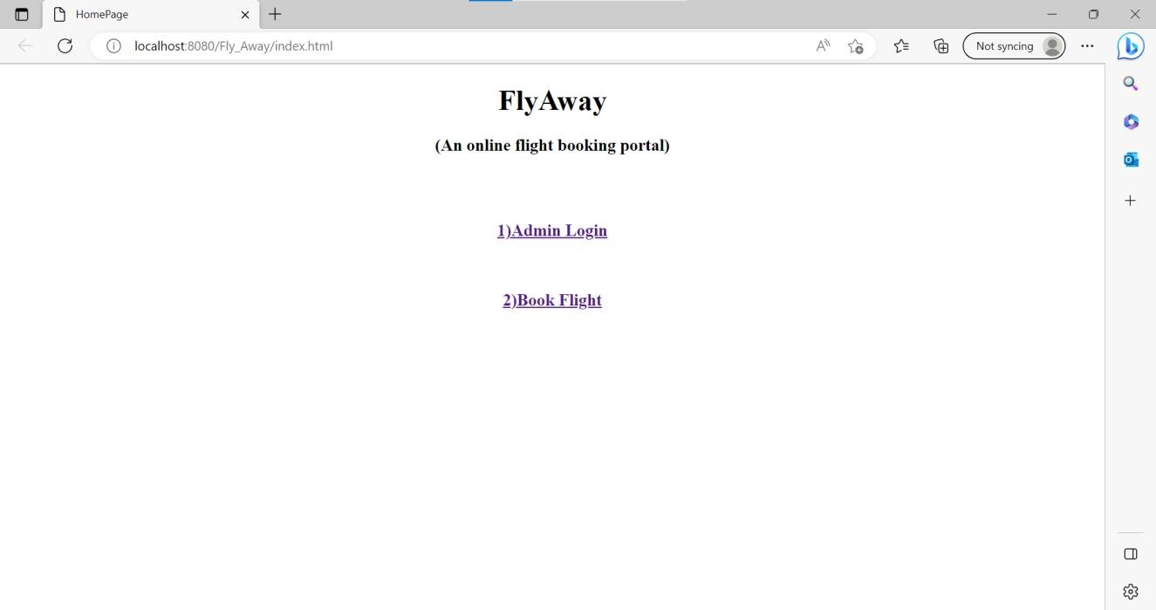

Fig 3.5: Main page assignment

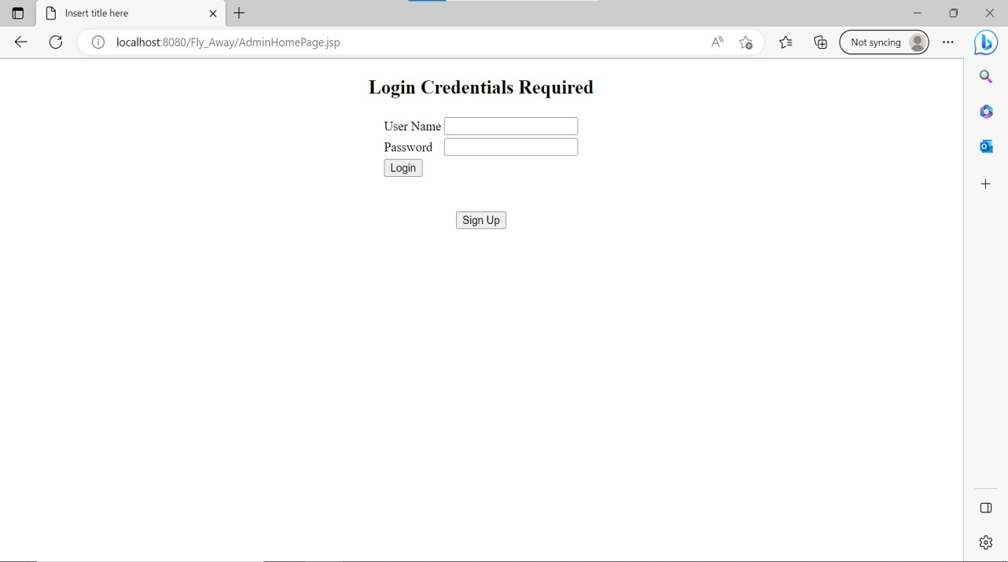

Fig 3.6: Login page



Fig. 3.7: Error message on wrong credential

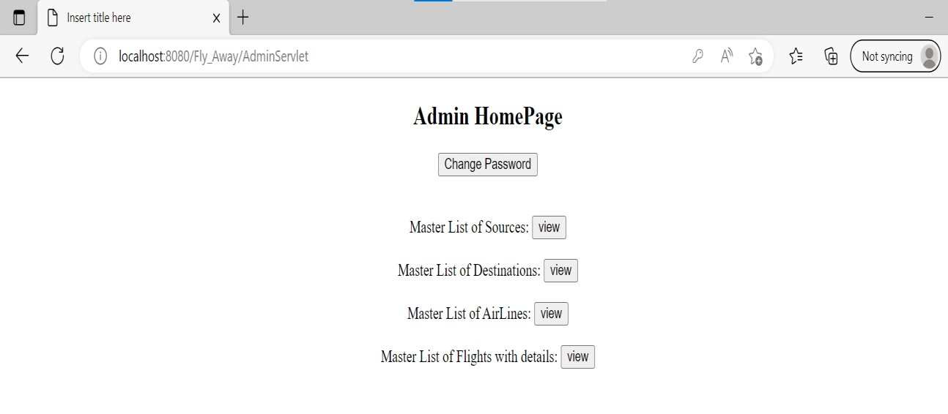

Fig. 3.8: Fully functional Admin home page

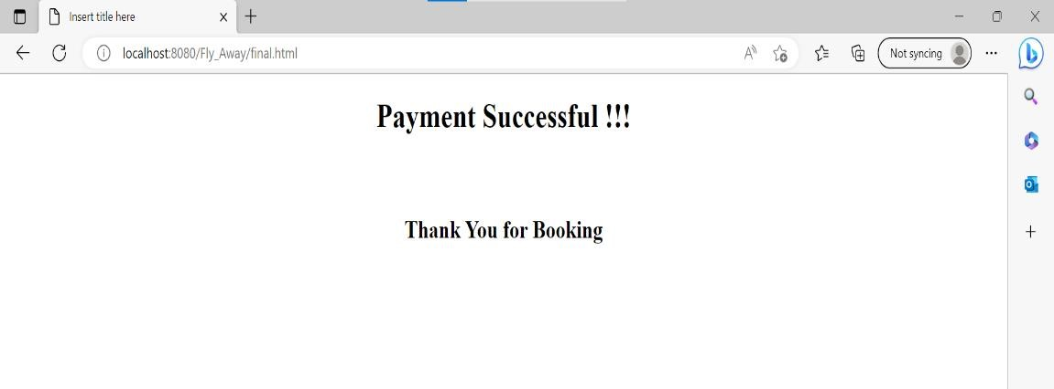

Fig. 3.9: Page for payment successful

### Assignment 3 Implementation:<https://github.com/harshit116/SimpliLearn_Project3.git>

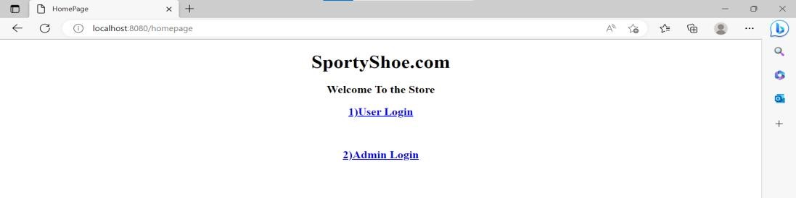

Fig 3.10: Main page assignment3

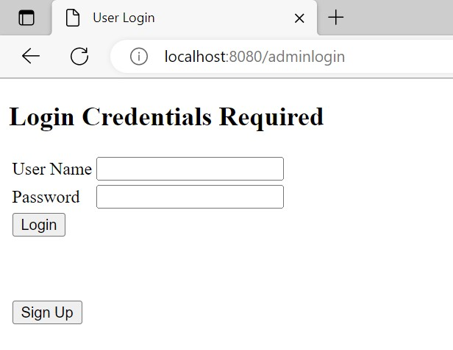

Fig 3.11: Admin Login

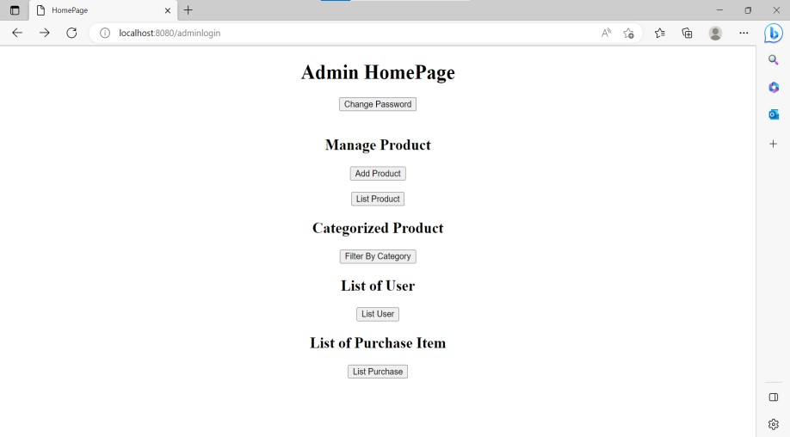

Fig 3.12: Home page

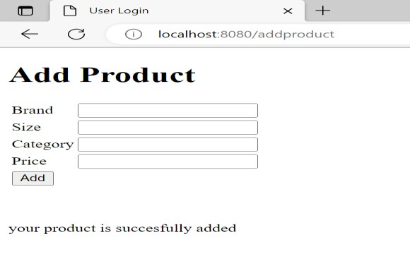

Fig 3.12: Add to cart page

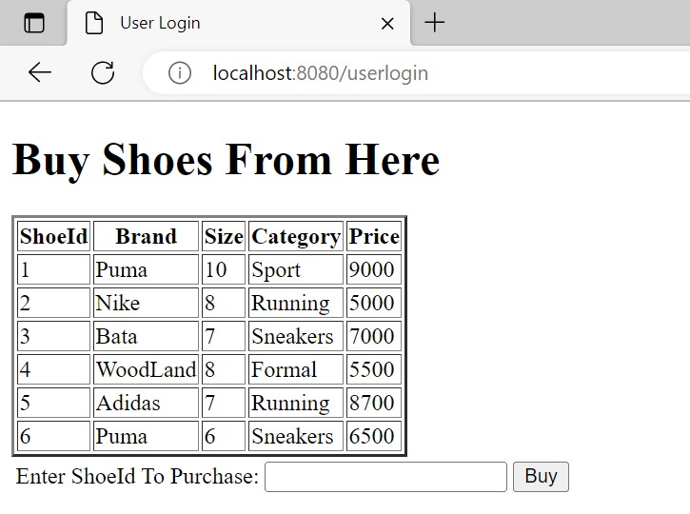

Fig 3.13: Product list page

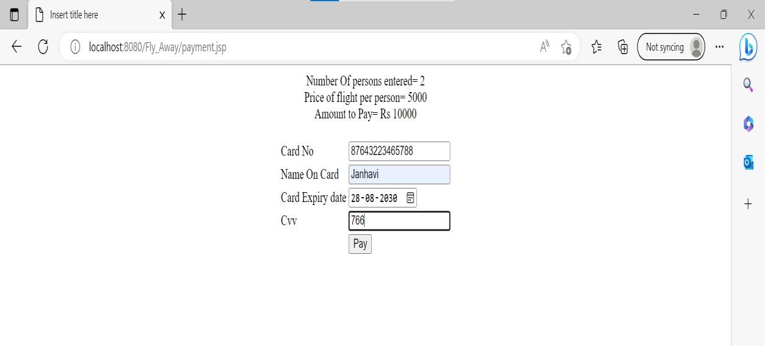

Fig 3.14: Dummy payments page

### **Assignment 4 Implementation:**<https://github.com/harshit6225/Quiz.git>

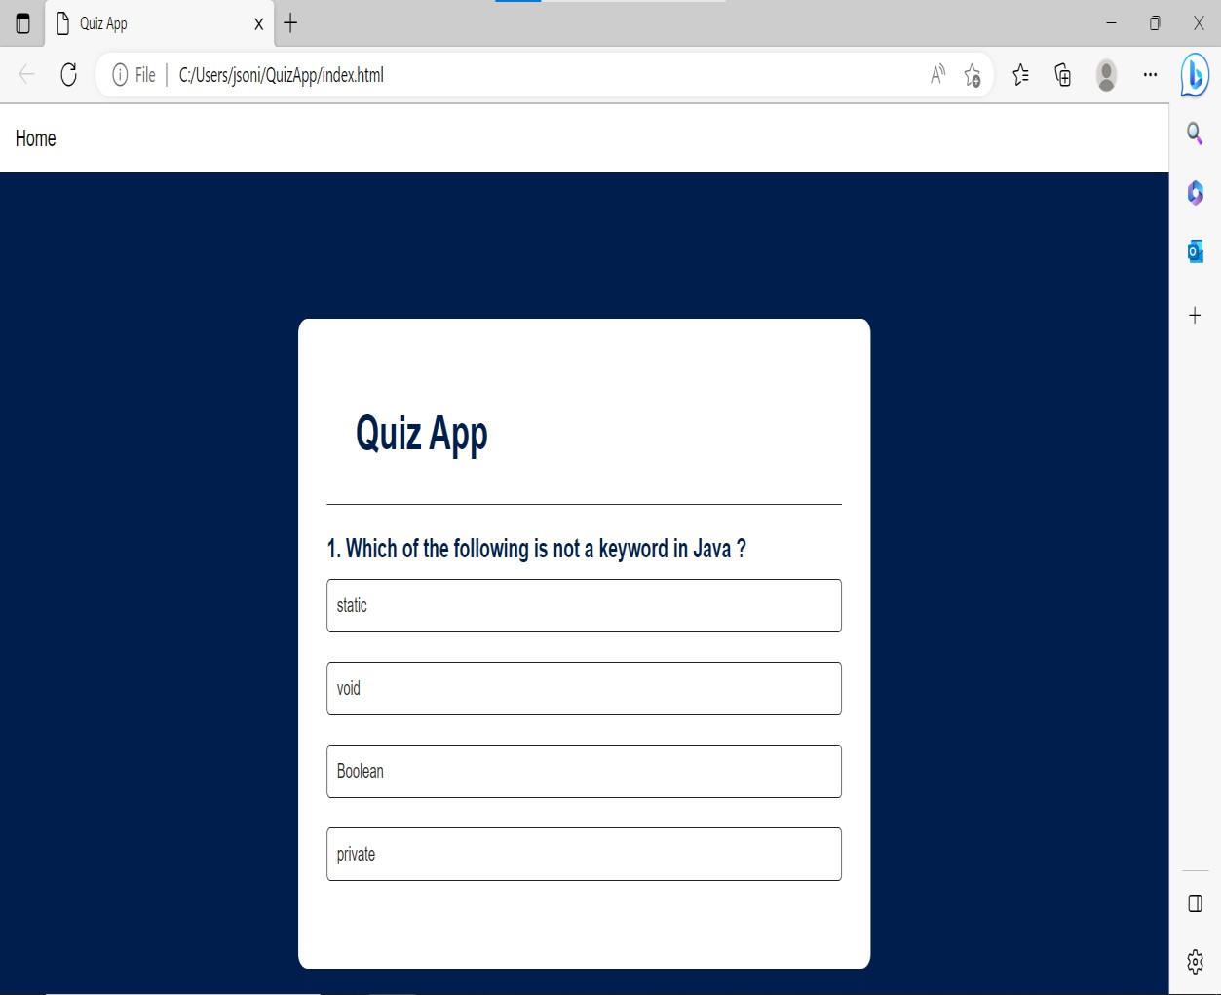

Fig 3.15: Landing page

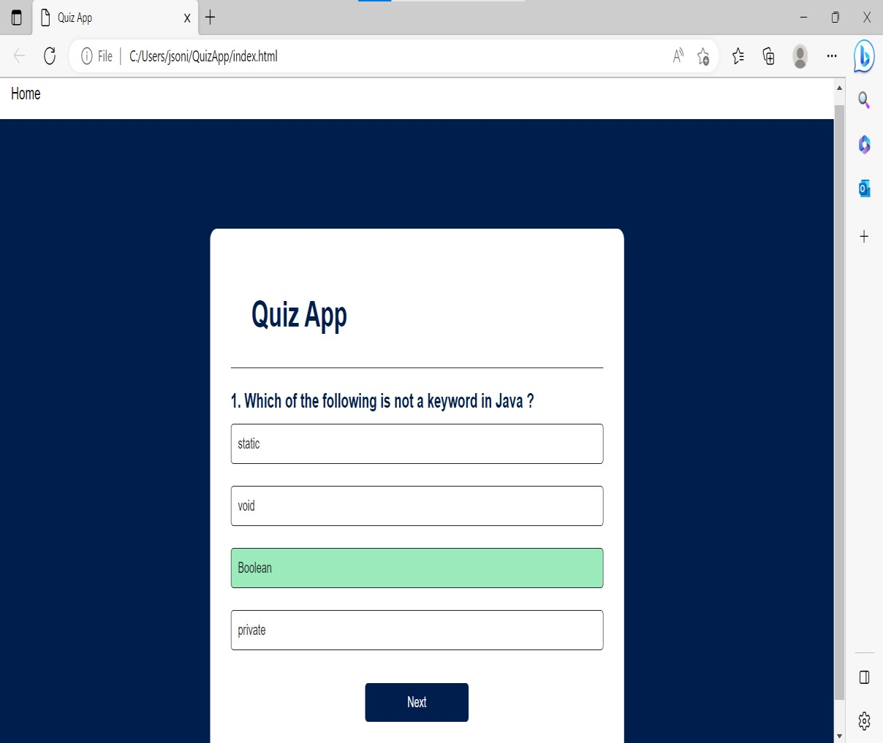

Fig 3.16: Selecting right answer

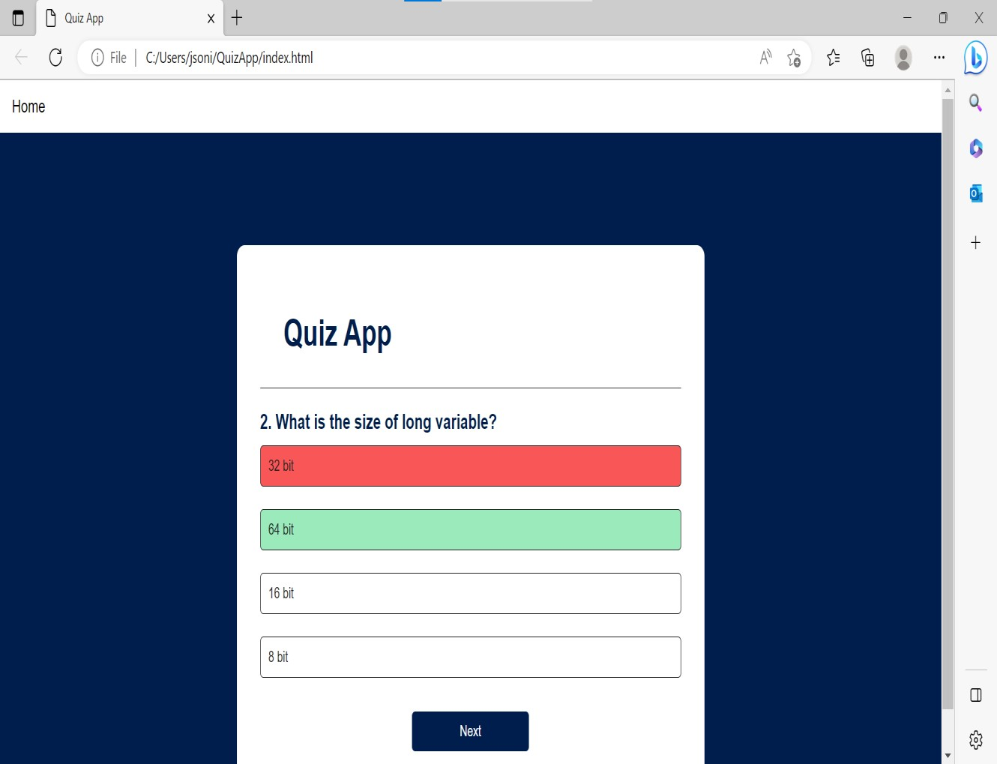

Fig 3.17 Selecting Wrong answer

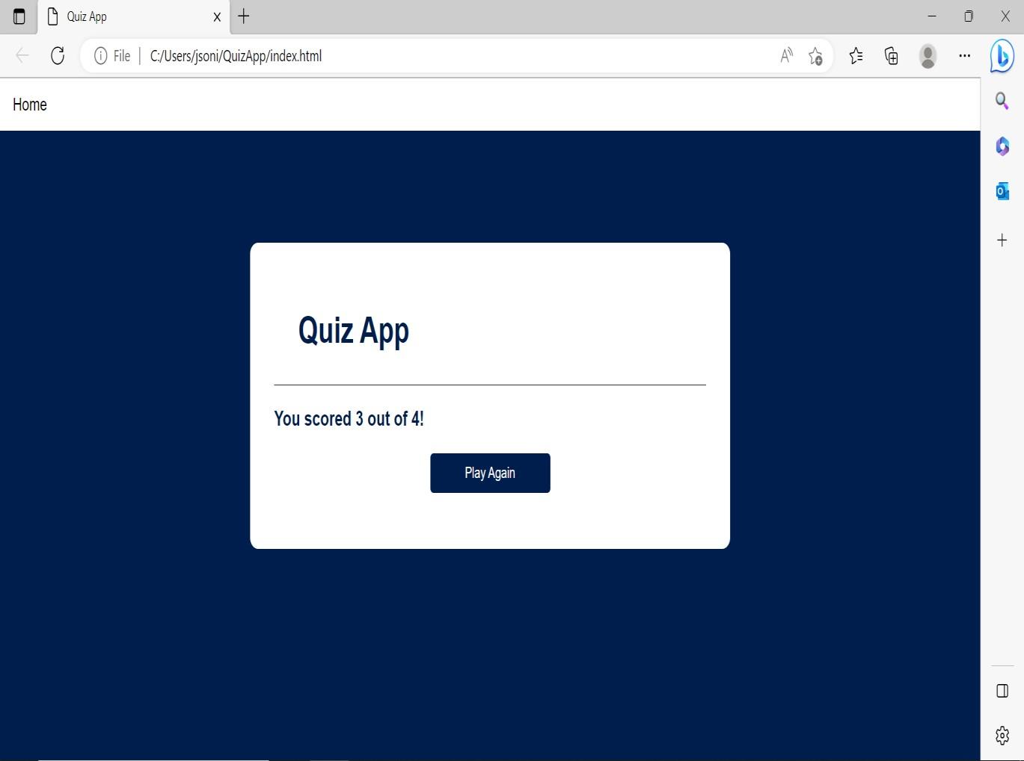

Fig 3.18 Result Page

### **Assignment 5 Implementation:** https://github.com/harshit116/pokemon.git

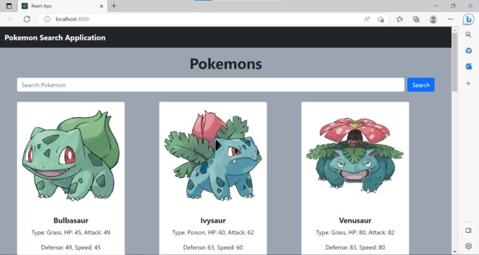

Fig 3.19 Landing Page

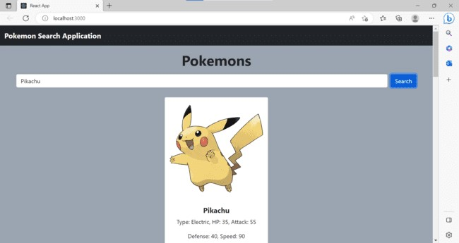

Fig 3.20 On searching a pokemon data is shown from database

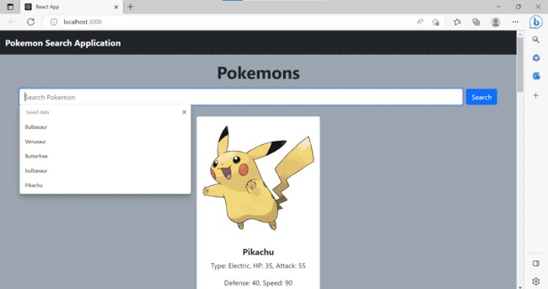

### Fig 3.21 Pokemon dropdown shown from database

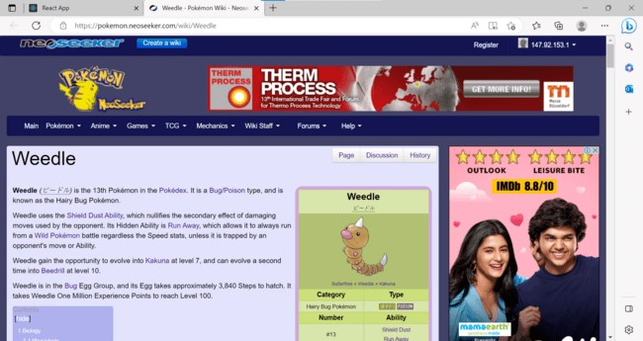

Fig 3.22 On clicking to read more, redirects to pokemon info page

**CHAPTER 4**

## RESULTS AND DISCUSSIONS

The result and discussion section for an internship project on Full Stack Development with React from coding to deployment using Docker at Tek System Global Services would focus on the outcomes achieved, challenges faced, and lessons learned during the project.

The project involved building a Full Stack Web Application using React on the front-end and Spring Boot on the back-end, and deploying it using Docker containers. The result section would highlight the specific tasks involved, such as designing and implementing the application's UI, developing the RESTful APIs, integrating the front-end and back-end, and deploying the application using Docker.

One of the key outcomes of the project was the successful deployment of the web application using Docker containers. Docker enabled the deployment process to be automated and streamlined, making it more efficient and less error-prone. The use of Docker also allowed for easy scaling of the application, which would be important in a production environment.

The discussion section would reflect on the challenges faced during the project, such as learning new technologies, debugging errors, and troubleshooting deployment issues. The discussion would also highlight the lessons learned from the project, including the importance of collaboration and communication in a team environment, the need for thorough testing and debugging, and the benefits of using Docker containers for deployment.

In conclusion, the Full Stack Development with React project using Docker at Tek System Global Services provided a valuable learning experience for the intern. The successful deployment of the application using Docker containers demonstrated the power and efficiency of this technology, while the challenges faced and lessons learned provided valuable insights into the development process and the importance of collaboration, testing, and debugging. Overall, the project was a valuable contribution to the intern's professional and personal growth.

**CHAPTER 5**

## CONCLUSION AND FUTURE WORK

As an intern at Tek System Global Services, I worked on a project to develop a full-stack web application using React, Spring Boot, Hibernate, and Docker. The goal of the project was to gain practical experience in software development best practices and tools and technologies that are relevant in the current tech industry.

To begin the project, I first learned the basics of React and built the frontend of the application. I used React components to create a responsive user interface and implemented state management using Redux. I also incorporated various libraries such as React Router for navigation and MaterialUI for styling.

Next, I worked on developing the backend of the application using Spring Boot and Hibernate. I implemented RESTful APIs to handle data requests from the frontend and integrated Hibernate to interact with the database. I also used Swagger to document the APIs and ensure consistency in the API responses.

Finally, I deployed the application using Docker. I created Docker images for both the frontend and backend and used Docker Compose to manage the containers. I also used Jenkins for continuous integration and deployment and AWS for cloud hosting.

Throughout the project, I faced several challenges that required creative problem-solving skills. For example, I had to debug errors in the application and optimize its performance. I also had to implement security measures to protect against potential threats and ensure the application was secure.

Overall, the project was a success, and I gained valuable experience in full-stack web development and DevOps practices. The project provided practical training in various tools and technologies such as React, Spring Boot, Hibernate, Docker, Git, Jenkins, and AWS, which are relevant in the current tech industry.

As a result of the project, I gained confidence in my software development skills and learned to work effectively in a team environment. The project also highlighted the importance of agile methodologies in software development and taught me to adapt to changing requirements and challenges.

In conclusion, the internship project on full-stack development with React from coding to deployment using Docker at Tek System Global Services was a valuable learning experience that will be invaluable as I pursue a career in software development. The project demonstrated the company's commitment to providing practical training to interns and showcased their expertise in the technology services industry.

**CHAPTER 6 Appendix**

**\*\*\*A brief introduction of the organization**

1. **Brief history:** Tek System Global Services is a global technology services company that provides a range of IT consulting, outsourcing, and staffing solutions to clients across various industries. The company specializes in providing advanced solutions in areas such as digital transformation, cloud computing, cybersecurity, data analytics, and software development. With a presence in more than 80 locations worldwide and a team of experienced professionals, Tek System Global Services is committed to delivering highquality services and driving innovation in the technology industry.
2. **Business size** Tek System Global Services is a large company with a significant presence in the technology industry. They have more than 80 offices worldwide and employ a large team of experienced professionals, which suggests that they are a sizable organization. Additionally, the company has a diverse client base across various industries, which further indicates their significant business size.
3. **Product lines**: IT consultation, Staffing solution, Application Services, Digital transformation and data analytics.
4. **Competitors**: Accenture, Cognizant, TCS, WIPRO, Infosys, Capgemini.
5. **Brief summary of all the departments:** As an intern I have sparce idea of different summary of all departments at tech system global.

**\*\*\*Learning Experiences (Note: Max. 2 pages)**

1. **Knowledge acquired:** Programming skills, Software development process, Agile methodologies, Software testing and cloud computing.
2. **Skills learned**: Leadership, Team work, Professional communication, JAVA, Spring, Hibernate
3. **Observed attitudes and gained values**: Leadership, team play.
4. **The most challenging task performed**: Completed all the given assignment on time.

\*\*\***Strength, Weakness, Opportunities, Threats (SWOT) Analysis**:

Here's a SWOT analysis for Tek System Global Services:

Strengths:

Global Presence: Tek System Global Services has a presence in more than 80 locations worldwide, which gives them a broad reach and diverse client base.

Diverse Service Offerings: The company offers a range of technology services and solutions across various industries, which makes them a one-stop-shop for clients.

Experienced Professionals: Tek System Global Services has a large team of experienced professionals with expertise in various technology domains.

Innovation: The company is committed to driving innovation in the technology industry, which keeps them ahead of their competitors.

Weaknesses:

Dependence on Key Clients: The company may face risks due to their dependence on a few key clients for a significant portion of their revenue.

Limited Market Share: Tek System Global Services faces intense competition from larger players in the technology services market, which limits their market share.

High Employee Turnover: The company may face challenges in retaining their top talent due to high competition and attractive opportunities in the technology industry. Opportunities:

Digital Transformation: The growing demand for digital transformation services provides opportunities for Tek System Global Services to expand their service offerings.

Emerging Technologies: The company can capitalize on emerging technologies such as Artificial Intelligence (AI), Machine Learning (ML), and Blockchain to offer innovative solutions to their clients.

Global Expansion: The company can expand their global footprint by entering new markets and expanding their existing service offerings.

Threats:

Competition: Tek System Global Services faces intense competition from larger players in the technology services market, which may impact their market share.

Economic Uncertainty: Economic uncertainty can impact the demand for technology services, which may affect the company's revenue growth.

Cybersecurity Threats: The increasing frequency and sophistication of cybersecurity threats pose risks to the company's reputation and client relationships.

Overall, Tek System Global Services has strengths that enable them to compete in the technology services market, but they also face challenges in a highly competitive and rapidly evolving industry. By capitalizing on emerging technologies, expanding their service offerings, and retaining top talent, the company can continue to grow and maintain a strong market position.